* 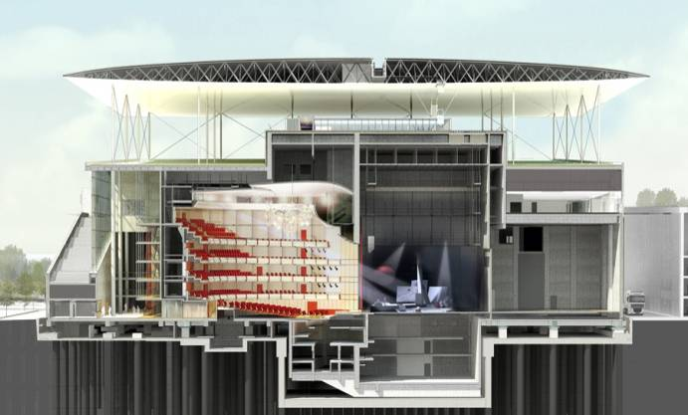Introduction

In terms of the construction of Stavros Niarchos foundation Cultural center, is one of the most innovative projects ever made, the 10.000m2 ferrocement canopy. The Opera’s canopy is consisted of 716 ferrocement panels, the construction of each requires high standards in terms of accuracy. To catch these high accuracy standards the panels are examined both in terms of geometric verification and quality control.

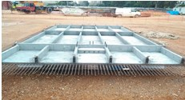 The geometric verification of the panel is performed by creating the 3d model of the panel. The geometric information is taken from the transverse and longitudinal sections at predetermined points. The requirements during the construction and checking of the panels are very high in terms of accuracy which cannot overpass the limit of 2mm.

The data examined for the geometric verification of each individual panel are:

* The distance between the ribs(Vertical Beams).
* 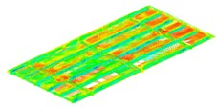The deviations of Ribs axes.
* The width of the ribs.
* The distance between the Beams.
* The deviations of Beams axes
* The width of the Beams
* The Flange Thickness

